MMP 200

Semester

App name

My name

TABLE OF CONTENT

Creative Brief

Persona

User Flows

Assessment of Prototypes

Design Specs

Artboards

URL of Final Prototype

CREATIVE BRIEF

Description
  - Describe what the app is about and what it enables people to do.

Purpose of mobile app
  - What is the reason for the application to exist? What need does it meet? What problem does it solve?

Target Audience
  - Describe the typical users of the app. Identify them by profession, age, comfort level with technology, needs, frustrations & pain points relevant to the app.
  - Describe how will the mobile app benefit the target audience.
  - Describe the context(s) in which they use the app (Where are they and what they might be doing when using the app)

User Tasks
  - From the user’s perspective, list the tasks that s/he can accomplish using the app (for example, ‘submitting assignments’, ‘checking grades.’)

Supported platforms
  - List devices supported by the app (android/iOS/web).

Competition
List similar apps and explain how you’re app will be different and/or a better fit for target audience.

Visual Style
  - Use adjectives to describe how your app will look like, for example, friendly, warm, cutting edge, clean, clear, etc. You may compare its style to other apps as well. Specify if you will adhere to existing design guidelines, such as those set by Google Material Design or Apple’s Human Interface Guidelines foe iOS.
PERSONA

Name – Age Occupation from City, State
  “A personal quote that provides an insight into the persona’s way of thinking” | Personal Background  - Short bio, including information that is relevant to the use of the app.
More About (add name) | Engagement & Activities
Motivations  Why would the persona be motivated to use this app?  Frustrations  What problems does the persona have that are relevant to the app?  Goals  - What are goals that the persona has that can be met by using this app? | Personal Computer: (technical comfort level, app used)  Internet Usage: (comfort level, websites used, activities)  Mobile: (mobile comfort level, features used, app used)  Social Networking: (social comfort level, service used and for what purpose)  Television Shows:

USER FLOWS

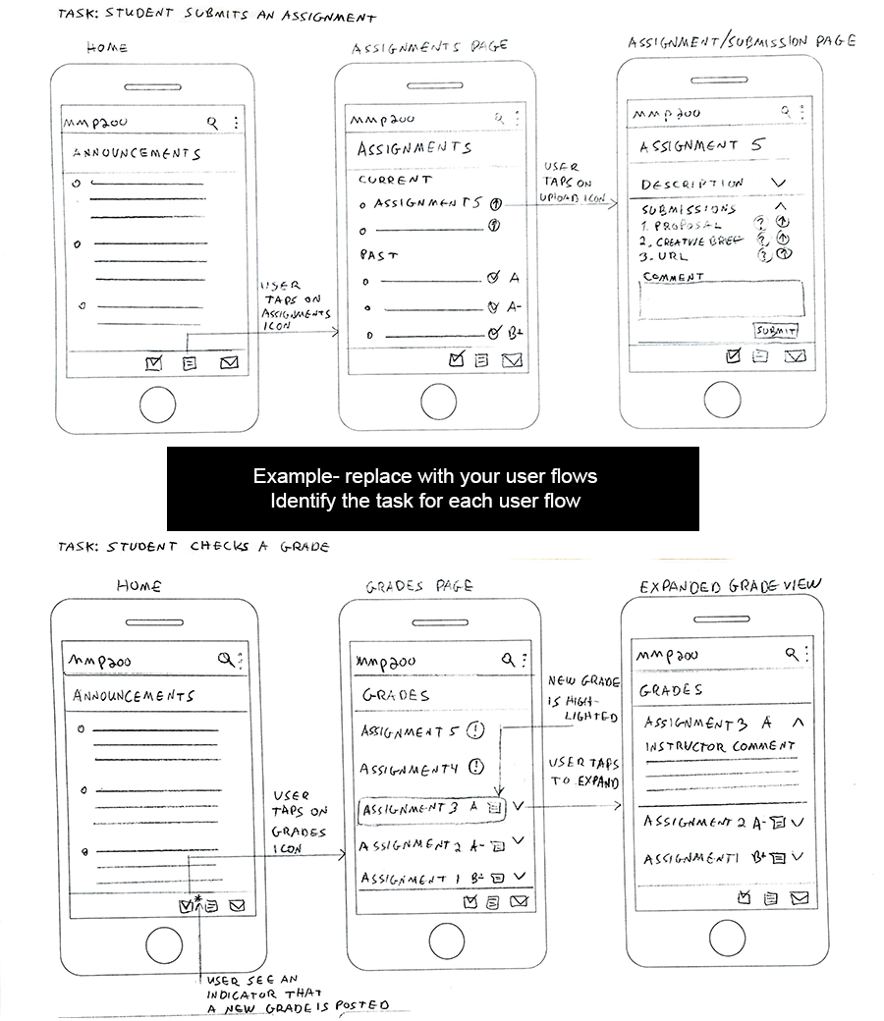

ASSESSMENTS OF PROTOTYPES

Low Fidelity Prototype
  - Describe what lessons you learned from the low-fidelity prototype and how you changed your app design in response to these lessons.

Second Prototype
  - Describe what lessons you learned from this prototype and how you changed your app design in response to these lessons.

DESIGN SPECS

Logo
Include an image

Layout and Spacing
All measurements in pixels
Device dimensions
Layout Grid
Number of columns
Gutters
Margins
Square grid (All elements, including text baselines, are vertically aligned to square grid)

Typography
Indicate font, weight, size and color
Titles
Subtitles
Body (include line-height)
Hyperlinks

Colors
Use Material Design color tool. Indicate hex numbers and include swatches
Primary colors
Secondary colors

Interface Elements and Components
Include images
Buttons
Input elements (if used)
Various control components (if used: dropdowns, accordion, slideshow controls, arrows, etc.)
Dividers
Decorative interface graphic elements (if used)

Iconography
Include images of icons in the sizes that they appear in the app.

ARTBOARDS

URL OF PROTOTYPE

