Child Case Study
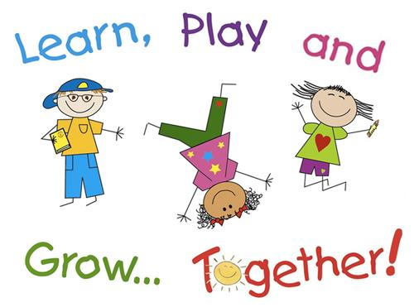

Bianca Jimenez
ECE 311
Professor V. Daley
Spring 2021
Table of Content
Child’s Background.……………….……………………………………………………………………...Page 2
Social Development……………………………………………………………………………………. Page 2-4
Physical Development…………………………………………………………………………………Page 4-7
Emotional Development………………………………………………………………………………. Page 7-9
Cognitive and Language Development…………………………………………………………. Page 9-10
Creative Work Samples……………………………………………………………………………. Page 11-13
Commentary…………………………………………………………………………………………. Page 14-15

Child’s Background
In this case study, I will provide an understanding of David’s physical, cognitive, emotional, and social development. Throughout this study, I will be observing this student, in a school setting. David is currently in Kindergarten and is 5 years old. He comes from a mixed family; his mom is white, and his dad is Puerto Rican. David lives at home with his brother, who is older, and two sisters, who are twins and are younger than him. I have not had the opportunity to meet his parents since he takes the bus in the morning and afternoon. Overall, David is always dressed presentable and is well kept. He is a very neat kid and likes to stay organized.

Social Domain
Running Record
03/10/21 11:45 A.M.
David walks outside to the yard. He immediately looks for his best friend Alex. He spots him over the swing set swinging with James and Kevin. He runs over and intervenes, “Come on Alex let’s play beanie tosser,” Alex says okay and runs off with David to the bean bag tossing station. “I want the blue beanie,” said David, and Alex said “okay I want a red beanie” David bends down and picks up all three blue bean bags. He dropped one on his way up from grabbing all three “oopsie” and he bends down to pick it back up. “You go first,” he told Alex. When it came to David’s turn, he got two out of three in. “awe man so close,” said David. “I win, I win,” says Alex.
03/10/21 12:50 P.M.
David gets out of his seat and walks over to the empty seat next to Alex. They start comparing their drawing project. “Look, I drew a super-duper fast car, look it has fire on the side,” says David “VOOM VOOM VOOM” he screamed, “it’s super loud,” he said “and look” he pointed to the stick figure he drew in the car “that’s me right there, I’m driving really fast... I’m going so fast,” he tells Alex. “And look that’s you” he pointed to the stick figure in the red car. “This is your car, it has fire on the side too,” David says to Alex “wow that’s so cool… I’m going really fast too, right,” asks Alex. “oooh yeah soooo fast. When we get older, we going to be the best NASCAR driver ever ever,” said David.
03/10/21 1:35 P.M.
David was put into a small group of four students which included Kevin, Clare, Charles, and David. I noticed he has not said anything in his group. I intervene and ask the group “what are you guys working on?” David shrugged his shoulders. Clare quickly said, “we are talking about our time we are really really really happy” As I was listening to Clare, David got up from his seat and crawled over to Alex’s seat where he sat on the floor and started to talk to Alex. “I guided him back and asked him to share his happiest experience with his classmates. “I am really happy when I and Alex were at my house and we were racing in our cars and we go really fast down the sidewalk … I am also happy when my mommy gets me a new Hot Wheels. I have a big truck and in the truck are a bunch of other cars and trucks and motorcycles,” said David. A few moments later when Kevin was speaking, David once again crawled away to Alex’s side.
Anecdotal Record
David’s friend Alex was absent from school today. When Alex is not in school David tends to be isolated from the rest of the students. At recess James asked David “do you want to play hide and seek with us” … “no” replied David. He grabbed his toy truck and walked to the reading center where no one was and laid on the floor. He pushed around his truck for a few minutes before he put his head down and took a nap till recess was over. I noticed when Alex is present in school David is willing to play with other students but when Alex is not there David does not play with the other students. He becomes anti-social, even when other kids offer to play with him, he always declines the offer.
Descriptive Review
Over the last few days working with David and watching him engage with others I noticed he likes to stick with one student. Alex is David's neighbor, so they have been friends for a very long time. David only engages with others when Ms. Lee or I make him. Other times he likes to play with the students who are playing with Alex. It is hard for David to communicate with other students but over the last few days I would pair different students with him so he can get used to working and playing with other students. David takes pride in his work with Alex and is most comfortable when he is in his company. They share games and play together. David talks with Alex and shows creativity and his personality really comes to life when they are together. David has a hard time showing empathy for others feelings. When David wants to play with Alex, he just asks him and no other student disregarding them. He lacks confidence when it comes to socializing with other students like he does with the adults in the room. He rather join in on a conversation with Ms. Lee and me.

Physical Domain
Running Record
3/15/21 10:21 A.M.
During math, the students were asked to thread 20 beads on a string of ribbon in a pattern of their choice. David chose the pattern: blue, green, yellow, white. He rolled the tip of the ribbon to make it smaller in order to go through the hole easier. Then he held it up to his eyes and squinted as he put the ribbon through the blue bead with a lot of concentration. He repeated these 19 more times. He dropped a few beads on the floor when picking them out of the jar.
3/15/21 11:45 A.M.
The learning objective in the gym this week is learning to dribble a basketball. When he bounces the ball in his left hand, he can control the direction but when he bounces the ball in his right hand it seems to go everywhere but straight down. He cannot dribble the ball and walk at the same time either. He keeps his eyes on the ball at all times, when he lifts his head up and off the ball, he loses control of the ball.
3/15/21 1:12 P.M.
For the last period of the day David and his class had dance movements. “David shouted can we do the the the skeleton dance?” So, Ms. Sue. played that song first and David started dancing but not the correct dance. In this song, you need to pay close attention because you have to listen to the directions of the singer. “That is not the dance mister,” said Ms. Sue “ok ok I just love this song sooo much Ms. Sue”. When the song says move your shoulders up and down, David would shrug his shoulders up and then drop them down over and over following the direction perfectly. Then came moving his knees up and down and side to side. David was able to do every part.
Anecdotal Record
During Movement David was presented with 3 different exercises: 10 jumping jacks, jumping over a square, and lastly balancing on 1 leg: 10 seconds for each. David did the jumping jacks, he counted out loud in a high voice “1, 2, 3, …., 10”. During the jumping jack task, he would jump without opening his legs and he swung his arms up and down in front of himself instead of to his sides. When jumping over the square tile he got in a running stance and counted to 3 “1, 2, 3, “when he got to 3, he ran and jumped landing on both feet. He did this task 6 times. When it came to balancing on one leg, he struggled halfway by putting his foot down only a few seconds in and then right back up when he caught his balance. “One more time, one more time. I can do it.” He did it again but kept falling before he hit 10 seconds. He did it with his right leg next and was able to balance for the complete 10 seconds. He jumped up and down saying “I did it, I did it, I told you”.
Descriptive Review
When David enters the room, he is energetic jumping up and down running into the room. We can come to the conclusion that David’s gross motor skills are well-developed since his moves are consistent. Although David was able to complete the task, he needed to be redirected constantly. The moments when David is most active is when the class is playing in the gym, dancing or when outside on the playground. The lyrics to the song “The Goldfish” by Laurie Berkner are as follows: “… And they washed their hair, and they washed their ears, and they washed their tummies, and they washed their very long, fishy beards, and they washed their noses, and they washed their toes-es, and then they said …” David puts his hands on his head, he bends his fingers in and out on his head while moving his arms and shoulders in a circular motion, intentionally pretending to wash his hair. Then he puts his hands flat on his ears, his left hand moves forwards then backward while his right hand moves backward then forward. Then he picks up his shirt some and lays his hands on his belly and rotates both hands in a circular motion all over the platform of his stomach from the sides to the front, up and down. After, he puts both hands up to his cheeks scrunching his fingers in and out in an attempt to wash his beard. He takes his index finger and his middle finger and puts them together and lays on them on each side of his nose, he scrunches his nose and eyebrows, he squints his eyes, and he rubs his fingers on his nose up and down. Then he squats down to his feet and he rubs his sneakers in a circular motion with his hands flat out. As we can conclude from this experience, David was using his gross motor skills to in-depth cleaning different parts of his body. As for his fine motor skills, David lacks the ability to continuously and correctly thread beads through a piece of string. David takes his pointer finger and his thumb to pick up the beds. He would pinch the beads too hard, and they would pop right out of his fingers. David’s left hand is more dominant when bouncing the ball. To improve his fine motor skills David can continue to use songs like the one above to build strength in the small muscles of his fingers.

Emotional
Running Record
3/18/21 10:30 A.M.
During reading the students were asked to choose a book to read and write and or draw their reaction to. David chose Race Day by Gail Tuchman to read. He drew the man on page 6 who is getting in the race car through the window. When it was time to present their drawing to the class David got excited. “This is me going in my car, I am racing and I'm going to win.” David said. “Is that what you want to be when you grow up?” asked the teacher. “Yesssss” he smiled so big from ear to ear.
3/18/21 11:15 A.M.
Every gym class David chooses to play with the soccer ball for choice time. During this class after the objective David ran over to the bag full of balls and noticed Luna took the soccer ball first. David stomped his feet as he walked over to the chair with his arms crossed with an angry face on. Mr. Herrera walked over and asked what the problem was. “I want the soccer ball,” said David. “Why don’t you go over and play with Luna then?” said Mr. Herrera. David walked over slowly and eventually asked “can I play with you?” Luna agreed and they started kicking the ball around.
Anecdotal Record
David put his head down at math time. I asked, “what’s the matter David, are you okay?” … “no, I don’t want to do the math,” he said. During math today the objective was to use building blocks to subtract two, one-digit numbers. The first question was 8 - 5 = ___, even before attempting the question, David started complaining. “I don’t know. I don’t want to do this,” he says. I told him “why don’t you give it a try” … “it’s too hard” he grunts. I told him I’ll help him with the first question. I showed him 8 cubes as stated in the question. Then I put 5 cubes in my pocket, and I asked, “how many cubes do you have left?” he counted “1, 2, 3, … I have 3” he said. “That the answer, good job. Now can you do the next question just like we did?” I replied. “Ok,” he said. The question was 5 - 3 = ___, “look” he said “5 cubes … I put 3 cubes in my pocket” as he puts them in his hoodie pocket. “1, 2, … I have 2 cubes” he smiled. He did it all on his own. The last question was 9 - 4 = ___. Instead of putting 4 cubes away he only put 3 away “I have 6 cubes now” he said. “How many did you put in your pocket,” I asked, he took them out and counted “1, 2, 3. 3,” he said, “look at the question, how many does it say to take away,” I asked. He got upset “4,” he said, and he put his head down.
Descriptive Review
David tends to express his feelings through his body language and his behavior. He will only express his feelings when asked a few times. Generally, he has a happy demeanor especially when he is around his best friend. At times he does have trouble talking to his peers or engaging with them for a long period during group time. He often has to be told to speak up and engage in conversation. There have been instances where David would express frustration specifically when he does not want to do something or when he is struggling to accomplish a task, usually math. He gave up very easily during math time although he is so good at counting and subtracting with a little help. During gym class, at first David expressed his disappointment and anger when someone else had the soccer ball by stomping his foot and crossing his arms. He was only able to deal with the problem when Mr. Herrera suggested to him to ask to join in. He seems to lack the confidence and skills to interact with other children.

Cognitive and Language
Anecdotal Record
In the dramatic play area, David was playing with the Legos. Carter walked over to him, “can I play with you?” he said. “Okay, I am building a sword (out of Legos) and this is my electric zapper (picks up a toy banana), it shocks people when I point it at them, look” as he points the banana at the teacher (who knows about his story). “Ouch, David, that hurt” she said. He laughed. “Cool” said Carter. Carter built his Lego sword, and they began to play. “Zap Zap” said David as Carter ducked.
Checklist
Cognitive and Language | Y | N
Carry on a meaningful conversation with another person
Talked about or tells stories. They have little or no trouble being understood by others
Speaks very clearly
Explores the properties of objects
Can count 10 or more objects
Draws a person that includes a head that looks like a head and at least one other body part
Correctly names at least four colors | N/A | N/A
Knows about things used every day in the home | N/A | N/A
Uses future tense
Tells longer stories
Descriptive Review
When listening to David talk with other students he tends to stutter over his words. I've notice that when David is sort of being forced to speak he tends to repeat words nervously. He does this quite often. On the contrary he also repeats words when he is overly excited as well. He is able to have a full conversation and make out accurate sounds. He doesn’t make too many mistakes when speaking, although his spellng is not accurate. He shys away from talking with classmates unless he is told to multiple times. Even then he only says a few words. David wouldn’t just walk up to a classmate and start a conversation, a peer has to come to him and they need to engage first. Once he is confortable then he opens up and is social. I notied once that time is up and the students need to go back to their seats he goes back to being isolated and shy. He is able to concentrate on a task long enough to get it done with minimal to no redirection.

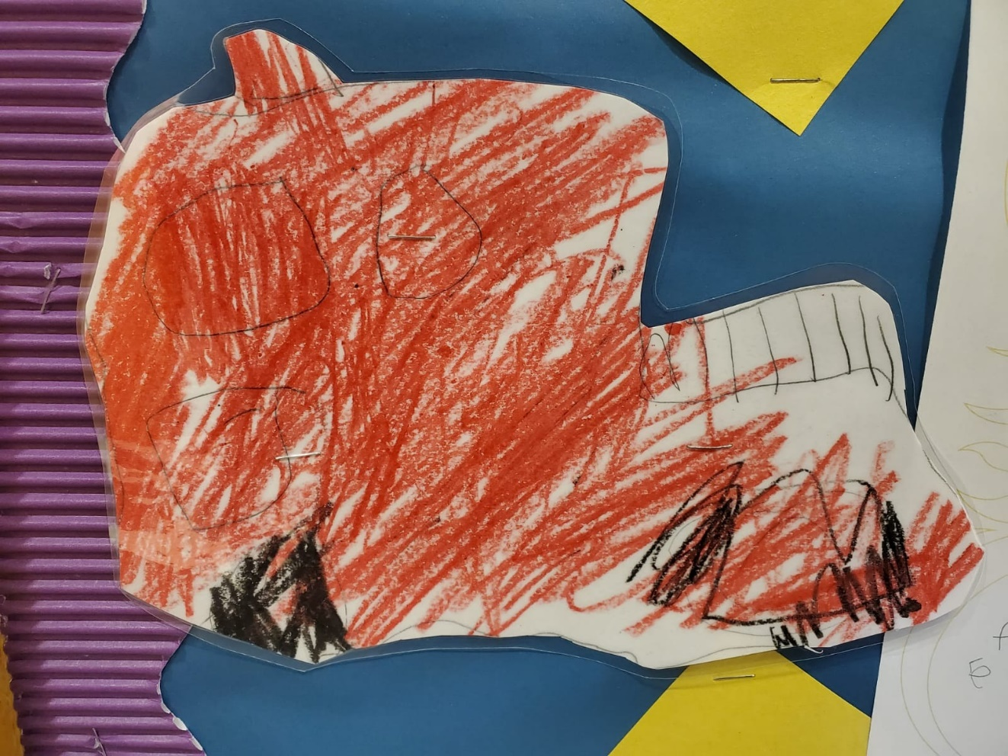
Work Sample 1

During this lesson on Community Helpers: Fire Fighters, David was asked to draw a picture of something that is associated with Fire Fighters. David chose to draw a fire truck. David’s fine motor skills are definitely present in this piece. Looking at it, David is capable of holding a pencil, crayon, and scissors. He does put force into coloring in areas of the paper. I asked David why he drew a fire truck he stated, “I like the color red, and this truck is very very red and big.” Based on this drawing and previous drawings of David’s, this one was definitely rushed. During this lesson he was very eager to go play.

Work Sample 2

In this piece, David was asked to make a card or drawing for his mom for Mother’s Day. David’s statement on this artwork was, “I drew hearts for my mommy. See I drew mommy and me.” He then started talking about the different colors he used. “Look, look, I used red, my favorite color is red, and pink, and orange. Orange is my mommy’s favorite color.” I asked if he was going to write something for her and he responded with, “No.” I suggested writing Happy Mother’s Day on the other side but that never happened.

Work Sample 3

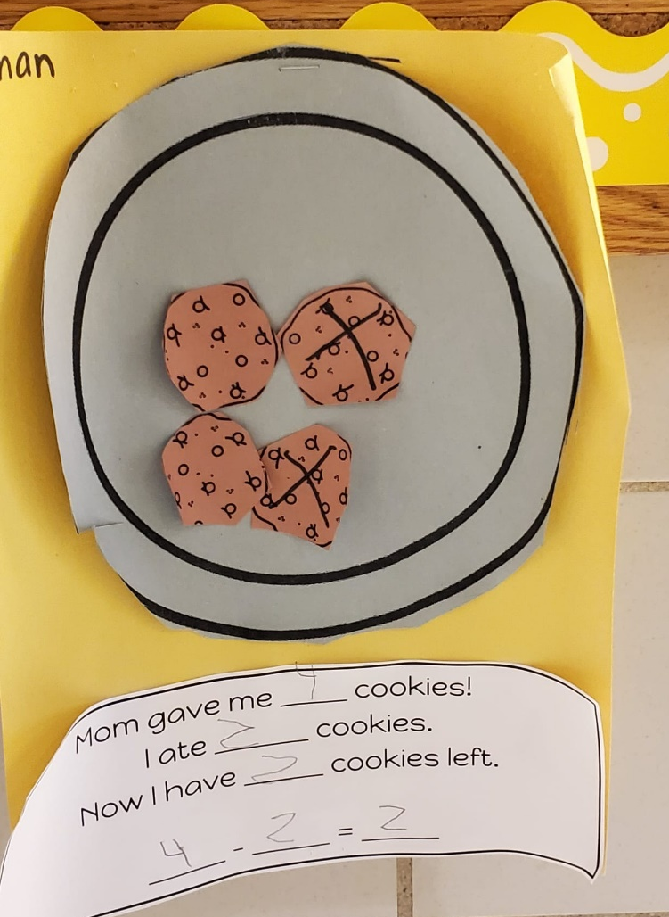

In this sample David was told to make a math problem using cookies. For this activity he was told to cut out as many cookies as he wanted along with cutting out the plate. David’s cutting was close to accurate. Looking at him do this assignment he concentrated on making sure he did not go over the line. After Davis cut out all his pieces, he glued them to the plate. Now he had to take away an X number of cookies. He marked them with an X. I asked why he chose to “eat only 2?” and he responded with, “when my mommy gives me my lunch there are always 2 cookies.” He answered the questions on the little sheet of paper creating a number sentence.
Commentary
I initially chose David to observe because I noticed that he is shy, but I also noticed that he is imaginative and creative, and I know that if he had the chance, he can be very outgoing and shed that shyness away. He is very passionate about the things he likes and the people he is comfortable with.
Throughout the course of the semester there have been very subtle differences I've noticed in David’s cognitive, language, social, emotional and physical development. David had made many improvements, but some things just stayed the same. In the beginning when I first met David, he didn't enjoy many aspects of school. He didn't like doing work because if it wasn't a topic, he was interested in then he didn't want to do it or if he wasn't good at it then he would give up without even trying. He didn't like to participate because he is antisocial, and he also wasn't making the effort to step out there and open up. He got upset and aggravated when things didn't go his way. But at the end of the term, he got better at trying and practice makes perfect. He learned that you have to try new things in order to know if you would like it or not. Although he is still not comfortable with everyone and isn't a social butterfly, I do see him becoming more comfortable with a few more students than just his best friend. Although he still throws tantrums and gets upset when things don't go his way, he responds positively to being talked to and redirected. Overall, David needs to become more comfortable and accepting of new things. Of course, things don't happen overnight, and you always need a starting point. I believe that taking what he loves the most, that being race cars, and applying it into more subjects. This way he is motivated into reading. He would want to try to read bigger more interesting books if it's about race cars or if math was about contained questions like "count how many race cars are ahead of your race car or how many race cars are behind your race car" incorporating the topics students like will motivate them to complete the work and or challenge them to a new reading level or harder math questions. As for David's social development, I feel like the teacher can find other students who have similar interests to be seated next to one another at least for some of the time so that they feel happy that someone knows and likes the “stuff” they do. That would make a student like David more social.

